# Introduction

The Switch Adapted Nerf Gun is designed to be a switch adapted toy for an older audience. The majority of switch adapted toys are designed for a younger audience, so this project aims to adapt a toy aimed at older users and make it switch accessible.

# Research

|  |  |  |  |
| --- | --- | --- | --- |
| Commercial | | | |
| Name | Image | Price | Link |
| Switch Adapted modified Dart Blaster. For special needs. |  | $99.74 | [Link](https://www.etsy.com/ca/listing/648802112/switch-adapted-modified-dart-blaster-for) |
| Dart Gun – Switch Adapted |  | $70 | [Link](https://adaptabilities.net/en-ca/products/switch-adapted-dart-gun-assistive-technology-toy-for-special-needs-education-occupational-physical-and-speech-therapy) |
| Switch Adapted NERF Rhino-Fire Elite foam dart gun | NERF Rhino switch adapted large plastic double-barrelled toy sentry gun. | Price available upon email request | [Link](https://oneswitch.org.uk/page/shop-switch-adapted-nerf-foam-dart-gun) |
| DIY | | | |
| Name | Image | Price | Link |
| SWITCHED Adapted Toys - Nerf Rivals Khaos - Manual |  | Unavailable | [Link](https://www.switchedtoys.org/adapt-attack) |
| IATP- Switch adapted Nerf gun |  | Unavailable | [Link](https://www.youtube.com/watch?v=AM-woh1qSKs) |

# Requirements

## Goals

|  |  |
| --- | --- |
| G01 | Allow a Nerf gun to be operated by an accessible switch |

## Functional Requirements

|  |  |
| --- | --- |
| F01 | Add a mono jack to allow the primary user to control the feed motor |
| F02 | Add a toggle switch to allow the secondary user to toggle the flywheel motor |
| F03 | Add a stand that allows the gun to standalone on a surface and be mounted on a ¼-20 UNC system |

## Non-functional Requirement

|  |  |
| --- | --- |
| NF01 | Add a second mono jack to allow the primary user to operate the flywheel motor. |

## Constraints

|  |  |
| --- | --- |
| C01 | Design must still allow the gun to be used normally |

# Prototyping

When opening the gun, the circuit was found to be different from the circuit in the gun in the tutorial video. Minor changes to the procedure had to be made to adapt the feed motor trigger. The initial circuit diagram can be seen on the left, while the modified circuit diagram is on the right.

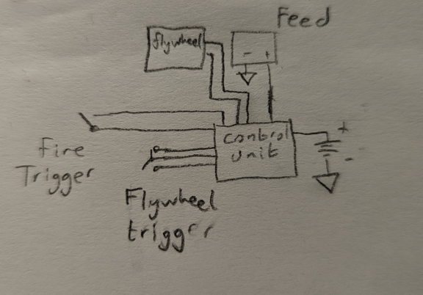 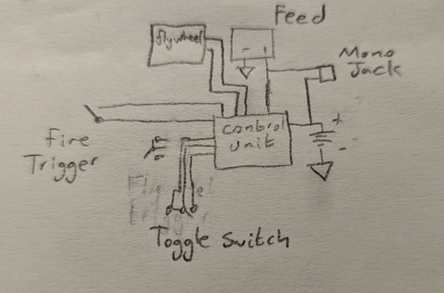

Two stands were designed for the gun. One bipod style desk stand was designed to fit over the attachment rail and allow the gun to stand upside down on a flat surface, while a ¼-20 bolt stand was developed that attaches to the gun near the centre of gravity and allows the gun to be attached to a standard ¼-20 mounting system.

# Testing

The successfully adapted toy was tested with a standard 3.5 mm switch using both the desk stand and the ¼-20 bolt stand. The gun was able to stand and support itself firing with both stands.

# Opportunities for Improvement

Once the control circuit is better understood, a 3.5 mm jack can be put in parallel with the toggle switch to make the flywheel motor usable by the primary user.

A system could be constructed to trigger both motors on the same switch, with a roughly one second delay on the feed motor to allow the firing motor to get up to speed.